Germán Martínez Cagigas
DAW
CMS DRUPAL

INDEX

Sumario
INDEX 2
INTRODUCTION 2
EXERCISE 3
Drupal. 3
2.1. What was the most challenging part of this activity? How did you manage to solve it? 8
2.2. Please investigate about a resource offered by Azure (other than the Virtual Machine). Explain briefly how it works and a possible use case. 9
BIBLIOGRAFIA 10

INTRODUCTION

CMS creation on virtual machine working as a server and connecting from other pc.

EXERCISE

Drupal.

Well i will use Drupal.
So, first of all a new fresh virtual machine on azure, on this virtual machine i activated rdp, port 80 and 443 are already activated so i didnt need added.

Now on our machine, i installed xammp, after instalation, i downloaded also the crt recurse from decroly from other activity with the certificate and the key.
On xammp folder i went into apache and created crt folder, inside of it i added the crt file and the key, so now i can connect throught https to my server not secure because it is an invalid crt but for the practice it works.
I also added the code of the figure 1:
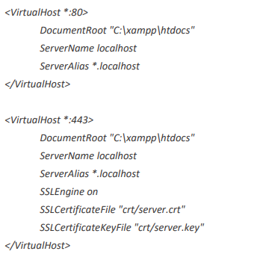Figure 1

Inside httpd-xampp.conf from xammp control panel Apache config.
Also we need add in our apache config php.ini the next code:
extension=php_zip.dll
or uncommented it, i didnt have it so i had to add that line, this will be necesary to unzip and install the CMS.

Now to install a CMS on xammp, all works in the same way, you download the zip, you go to xammp htcdocs folder and create a new fold, in my case named drupal and extract the cms zip there.
Now you go to your browser and write localhost/”your folder name” and the instalation will start after that, and now you add your name password, sql, prefix of the CMS on data base, etc.
After you will see revisions, checks, problems.
In my casei didnt see nothing but because i was trying other CMS before and i uncommented
on php.ini the next lines:
extension=gd.
extension=intl.
The installation will say what lines need to be uncommented, for example i was trying before this moodle and prestashop and moodle said sodium need to be uncommented i did it, but the library didnt charge for example, or prestashop with openSSL code, that i uncommented again but there was problems generating privating key, so i installed Joomla and didnt have any problem on the installation.
After that the installation is already done, you will acces to you web page with your credentials and will be logging on the dashboard.

Here is the installation process of Drupal on figure 1.
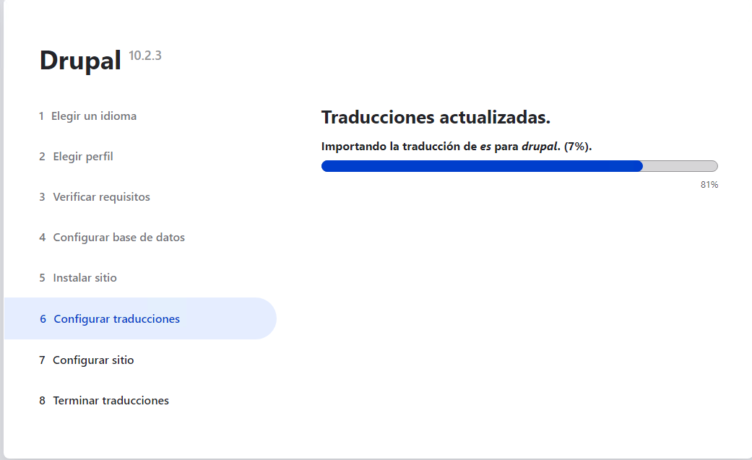Figure 1
And now to acces to it i only need write http://localhost/drupal/drupal-10.2.3/ on my local machine, or the ip machine instead localhost if i wanna connect from other pc, i could remove drupal folder and make the url shorter but whatever.
So lets take a look how looks the main page from client pc in a simulated scenario figure 2.
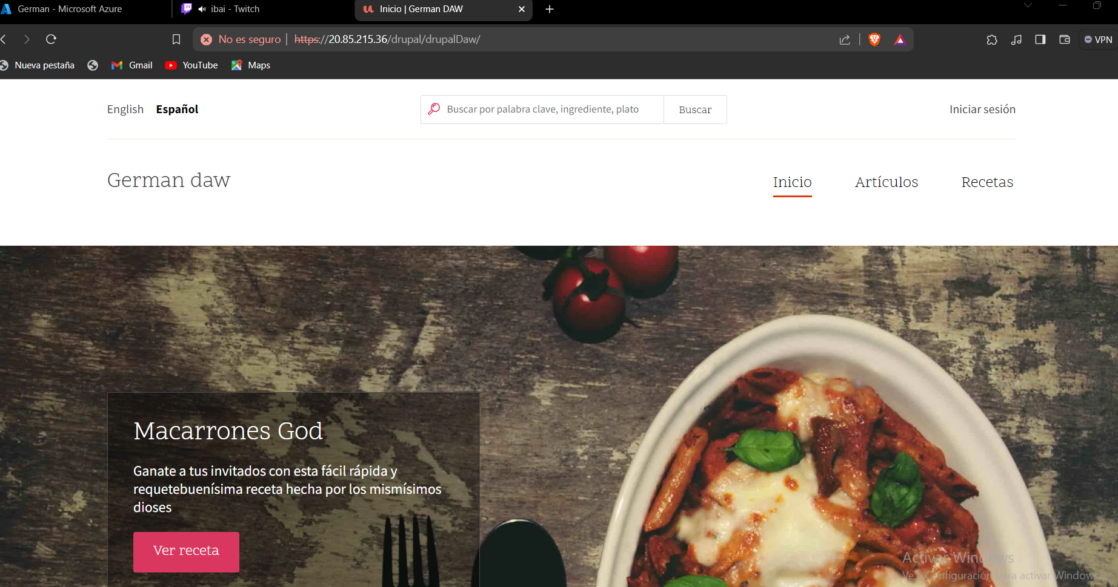Figure 2

Or the contact on figure 3.

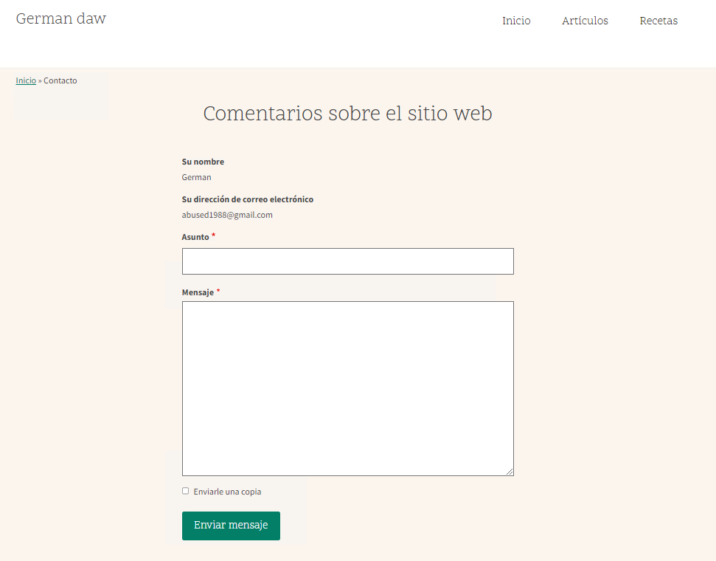Figure 3
Or the recipes in figure 4.

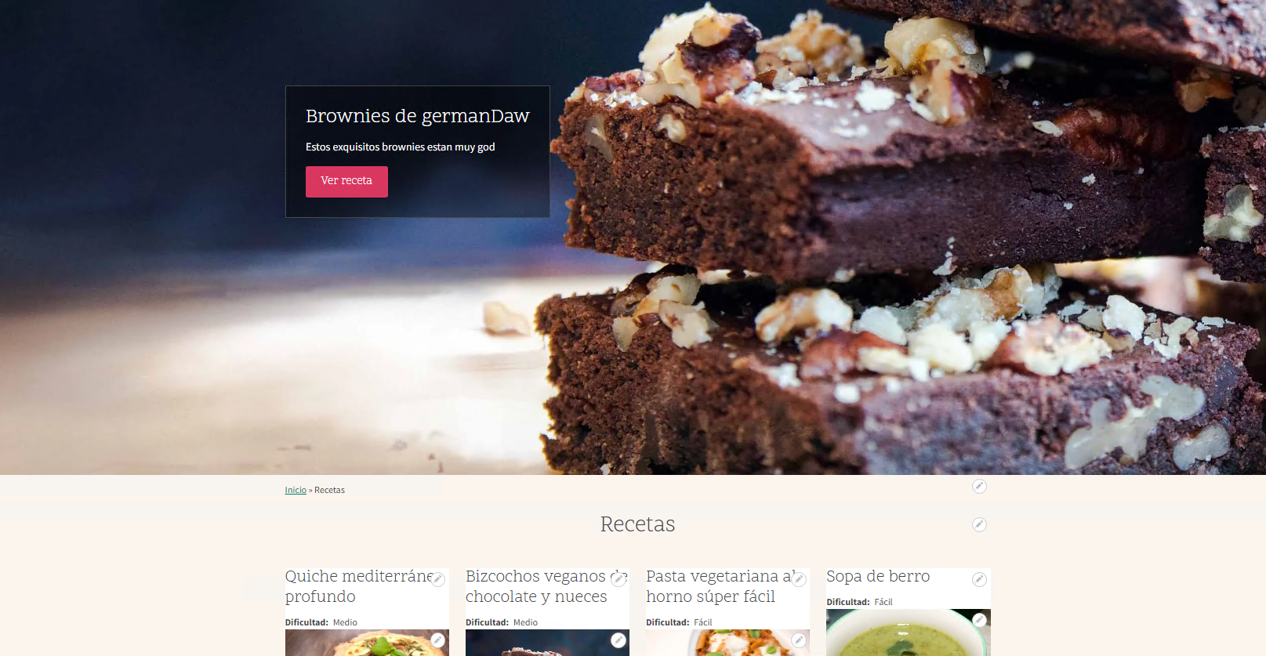Figure 4

2.1. What was the most challenging part of this activity? How did you manage to solve it?

I had many of them:
Moodle: Needed maria db 10.6 and my xammp had only until 10.4 version, also on php ini uncommented sodium but the libraries didnt charge, descarted.
PrestaShop: Uncommented on php ini openSSL line, still giving an error generating private keys, so descarted.
Joomla: I dont event know how to edit pages, too weird, not intuitive to add block, edit them, create full pages with custom layouts, i dont know, by far, the worst CMS i ever seen.
At the end, i just solved it installing other CMS regarldess day invested on joomla trying to know how to work with it.
At least i understand now why wordpress is the n1, is the most simple by far, install templator and design the web in a simple and intuitive way dragging and pulling blocks.

2.2. Please investigate about a resource offered by Azure (other than the Virtual Machine). Explain briefly how it works and a possible use case.

Azure blob storage is a cloud storage service that allow users to store images, files, videos… on the cloud.

You create your “vault” like your virtual machine.
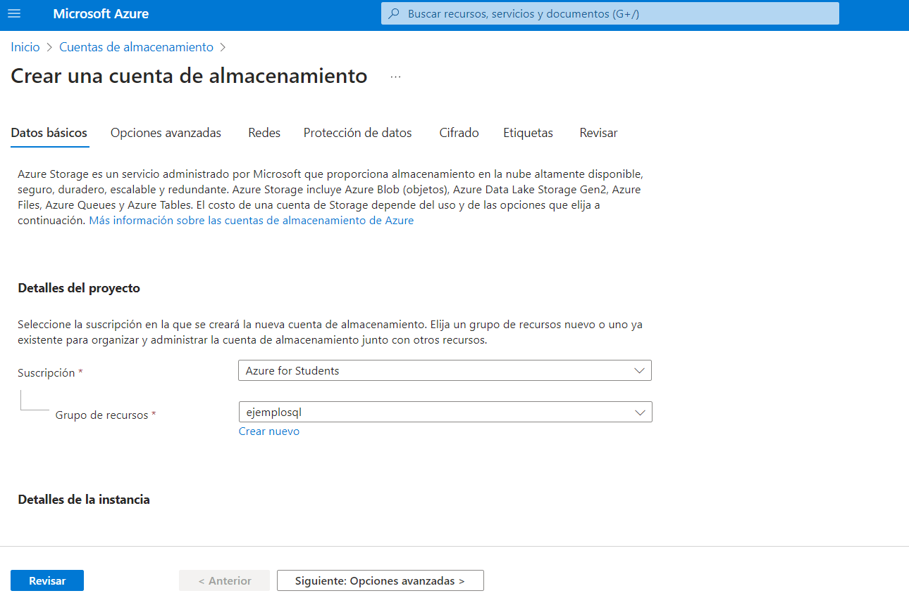Figure 5
Figure 5 is an example of the storage blob.
So after create it, you can push your files/images for example into it, so you will have 24/7 access to it, the security of microsoft, the backup, etc.
Or you could just use it to have important files in a secured place that if something happens you have a backup of it.

BIBLIOGRAFIA

file:///C:/Users/abuse/Downloads/DU2.3%20Evaluating%20performance.pdf

